Incoming FrII - French Summer Work 2024
Grammar Review:
- Explore 20 new nouns- find out their French translation and complete the following chart (all articles):

NEW NOUN (English & French translation) | Definite article  (Singular & Plural) | Indefinite article (Singular & Plural) | Possessive article (MY) (Singular & Plural) | Possessive article (YOUR) (Singular & Plural) | Possessive article (HIS/HERS) (Singular & Plural) | Possessive article (OUR) (Singular & Plural) | Possessive article (YOURS) (Singular & Plural) | Possessive article (THEIRS) (Singular & Plural)
Car voiture (f/s) voitures  (f/p) | LA/LES | UNE/DES | MA/MES | TA/TES | SA/SES | NOTRE/NOS | VOTRE/VOS | LEUR/LEURS

- Choose 10 “ER”, 5 “IR” & 5 “RE” verbs from the REGULAR VERBS CHART – conjugate all 20 verbs using the French Subject Pronouns – see below chart to recreate.
JE NOUS  TU VOUS  IL/ELLE ILS/ELLES | 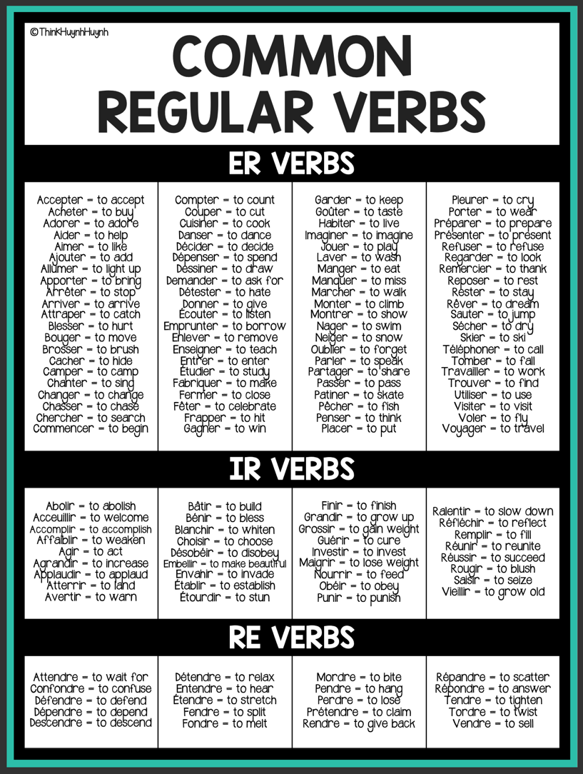

- CONJUGATE THE FOLLOWING IRREGULAR VERBS LEARNT IN 8th GRADE:

AVOIR |  | ÊTRE |  | FAIRE |  | ALLER |  | METTRE

- WRITE 2 SENTENCES FOR EACH IRREGULAR VERB – CHOOSE A VARIETY OF SUBJECTS, - PUSH YOURSELF! (WATCH ARTICLES, AGREEMENTS AND ADJECTIVE PLACEMENTS)

LISTNING:

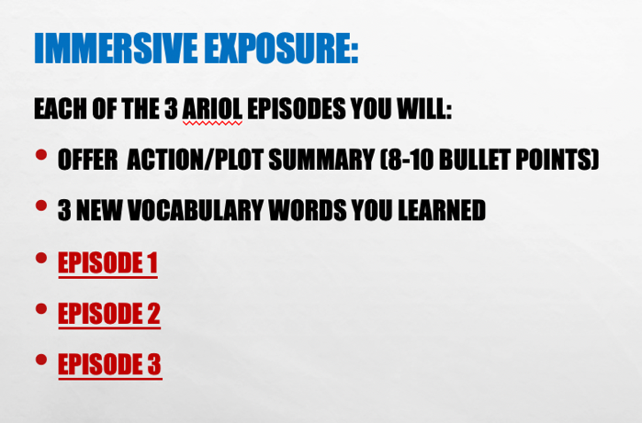

READING:

